Chapter 9, Problem 41.

Find v(t) in the RLC circuit of Fig. 9.48.

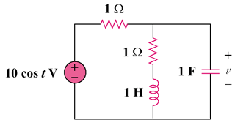

Figure 9.48
For Prob. 9.41.

